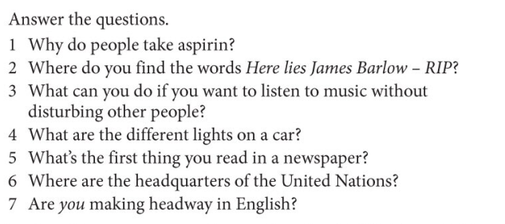
Every answer should include the word beginning with H

